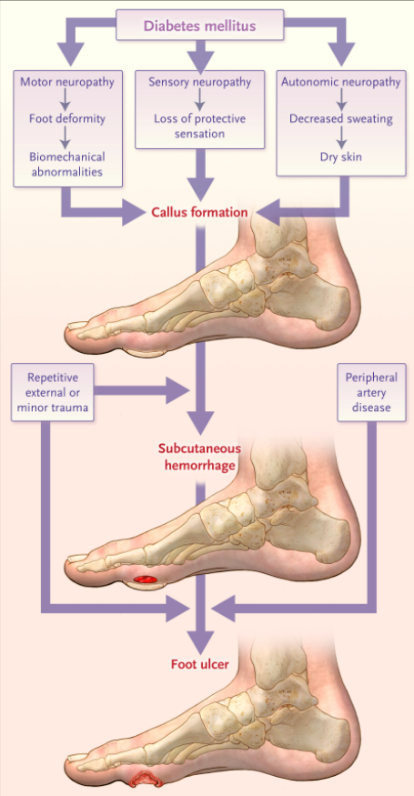
Diabetic Foot Infections
Background
- Annual incidence of foot ulcer among diabetics: 2.2% (5% among US veterans with diabetes) with lifetime incidence of 20-34%. Globally, > 9 million people develop a diabetic foot ulcer annually and more than half of these become infected¹
- Lower extremity infections occur in diabetics due to a confluence of risk factors:
  - Hyperglycemia impairs multiple aspects of immune response (chemotaxis, adherence, opsonization, phagocytosis)
  - Vascular insufficiency – impairs wound healing, delivery of Abx
  - Neuropathy – Local trauma, delayed recognition
- Most diabetic foot infections develop as the result of neuropathic or ischemic wounds
  - Not all diabetic foot wounds are infected, but all will have bacteria if cultured
Microbiology
- Often polymicrobial
  - For mild infection main drivers are Gm + (MSSA, MRSA, GAS, CoNS)
  - Deeper, necrotic infections have more gram negatives and anaerobes
- Pseudomonas aeruginosa is occasionally recovered, however it often doesn’t need to be specifically treated
  - SIDESTEP trial of 586 patients with DFI compared ertapenem to pip-tazo x at least 5 days followed by up to 23 days of amox-clav. Favorable response was 94% in pip-tazo arm and 92% in ertapenem arm (seen even in patients who grew pseudomonas)²
Diagnosis
- Based on clinical manifestations (two or more) NOT microbiology:
  - Erythema, warmth, tenderness, swelling, induration, purulence
- Severity assessment & amputation risk: PEDIS (Perfusion, Extent, Depth, Infection, Sensation)
  - Mild: <2cm of surrounding erythema, no deep structures involved, no SIRS
  - Moderate: >2cm of erythema, deep structures involved, no SIRS
  - Severe: SIRS present
- Ankle-Brachial Index (ABI) often performed to evaluate for underlying bone involvement and PAD
- When infection is present culture from deep tissue is helpful, the role of superficial wound culture is limited
Osteomyelitis
- Factors associated with osteomyelitis:
  - Bone visible
  - Probe to bone
  - Ulcer >2cm
  - ESR >70
  - Ulcer duration >1-2 weeks
- For grossly visible bone osteomyelitis is assumed to be present. For other factors the next diagnostic steps are:
  - X ray
  - MRI if X ray is normal or inconclusive

Management
- Wound care – Perhaps the most important component of treatment in getting ulcers to heal
  - Local debridement of necrotic tissue – usually with sharp debridement but can use enzymatic, autolytic, and biological debridement. Larval therapy has been shown to increase duration of antibiotic free days as part of ‘wound hospice’^{3,4}
  - Dressings to keep clean and moist (but not soaked) – no high-quality evidence for any specific dressing
  - Negative pressure wound therapy (Wound vac) may be a beneficial adjunct. Meta-analysis showed increased chance of wound healing (RR 1.4) and reduced risk of amputation (RR 0.33)⁵
- Antibiotics – Limited data to support any specific empiric regimen
  - For mild disease oral antibiotics for gram positives are usually enough (eg cefadroxil, cefalexin)
  - For moderate-severe disease usually use upfront IV antibiotics and add coverage for gram negatives and anaerobes (eg amp-sulbactam, Ceftriaxone +/- flagyl, Ertapenem)
  - If history of MRSA, add MRSA coverage (doxy or TMP/SMX for PO, Vanco or Dapto for IV)
  - If significant risk factors for pseudomonas can add pseudomonas coverage but generally not needed
  - Can narrow based on culture results
    - Often don’t need to treat every bacteria recovered (ie Enterococcus, CoNS)
  - Duration
    - If no osteomyelitis, treat until no longer clinically infected (1-2 weeks)
    - For osteomyelitis, it’s its own separate primer re Abx selection, IV v PO, but duration and role of rifampin remains unclear. Most would do at least 6 weeks but pilot study showed non-inferiority of 3 weeks⁶
- Surgery
  - Sharp debridement of necrotic soft tissue needed for severe and most moderate infections
    - Particularly important if abscess, joint involvement, necrosis, or crepitus
  - For bone involvement, debate over when bone resection and amputation are needed (likely needed for necrotic bone, but may not be necessary for infected but viable bone)
    - Appropriately, decision is often guided by patient preference
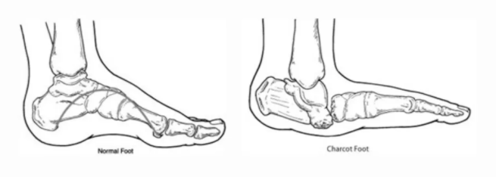
Charcot’s Foot
- Pathogenesis likely multifactorial with mechanical and vascular factors due to diabetic neuropathy and vasculopathy
- Development of Charcot’s increases likelihood of amputation by a factor of 6
References:
- Armstrong DG, Boulton A, Bus SA. Diabetic Foot Ulcers and Their Recurrence. NEJM 2017; 376: 2367-2375
- Lipsky BA, Armstrong DG, Citron DM, et al. Ertapenem versus piperacillin/tazobactam for diabetic foot infections (SIDESTEP): prospective, randomised, controlled, double-blinded, multicentre trial. Lancet 2005; 366:1695.
- Opletalová K, Blaizot X, Mourgeon B, et al. Maggot therapy for wound debridement: a randomized multicenter trial. Arch Dermatol 2012; 148:432.
- Armstrong DG, Salas P, Short B, et al. Maggot therapy in "lower-extremity hospice" wound care: fewer amputations and more antibiotic-free days. J Am Podiatr Med Assoc 2005; 95:254.
- Liu Z, Dumville JC, Hinchliffe RJ, et al. Negative pressure wound therapy for treating foot wounds in people with diabetes mellitus. Cochrane Database Syst Rev 2018; 10:CD010318.
- Gariani K, Pham TT, Kressmann B, et al. Three versus six weeks of antibiotic therapy for diabetic foot osteomyelitis: A prospective, randomized, non-inferiority pilot trial. Clin Infect Dis 2020.
- Wukich DK, Sadoskas D, Vaudreuil NJ, Fourman M. Comparison of Diabetic Charcot Patients With and Without Foot Wounds. Foot Ankle Int 2017; 38:140.

