Skin and Soft Tissue Infection ID Primer

Overview:

* Skin and soft tissue infections (SSTIs) are common – 16 million incident cases in the US in 20191
* SSTIs are the result of bacteria breaching the skin barrier, either from microtrauma or gross inoculation
* Clinically presents with erythema, edema, and warmth
* Erysipelas generally presents acutely (hours) with clear demarcations and without purulence
* Cellulitis usually more indolent (days), presents with or without purulence

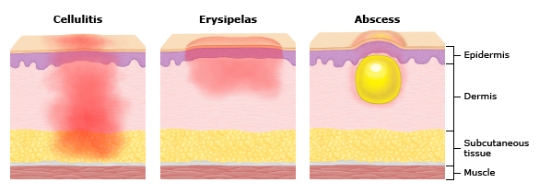

Microbiology of SSTI:

* Challenging to make a microbiologic diagnosis, infections tend to have low bacterial burden
* Commonly divided into [erysipelas and nonpurulent cellulitis] and [purulent cellulitis and abscess]
  + Erysipelas and nonpurulent cellulitis: Beta-hemolytic strep overwhelming majority (Group A strep in particular), some MSSA
  + Purulent cellulitis and abscess: Staph aureus is more common, MRSA becomes a concern

Treatment of SSTI:

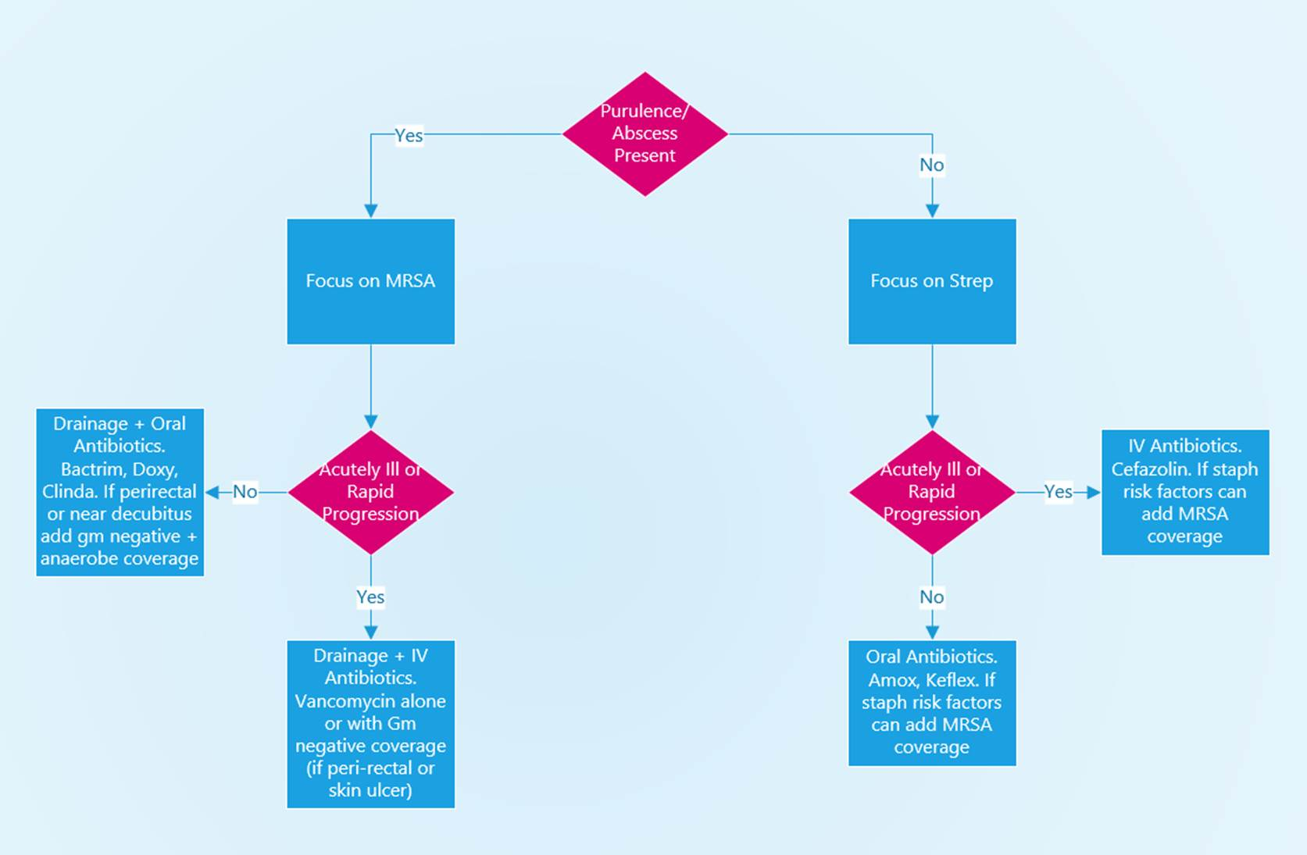

* No MRSA treatment if nonpurulent. Study of 153 patients with nonpurulent cellulitis showed no difference between Keflex alone and Keflex with Bactrim (82 v 85% cure).2
* Might add MRSA coverage if risk factors or acutely ill
* MRSA treatment if purulent. Study of 1220 patients showed Bactrim + drainage better than drainage alone for abscesses 2-5 cm(81 v 74% cure)3. Another study of 780 showed Bactrim or clinda with drainage was better than drainage alone for abscesses smaller than 5 cm. (82 v 69% cure)4

Controversies:

* Role of steroids or NSAIDs. Small studies suggest steroids or NSAIDs hasten clinical improvement in non-diabetic adults. Study of 51 patients with uncomplicated cellulitis on extremities. Improvement at 48 hours seen in 80% of ibuprofen group and 65% of placebo group. No adverse events but did not meet statistical significance5.
* The concern is masking or increasing risk for necrotizing fasciitis

Preventing Recurrent Cellulitis

* Compression Stockings: For people with LE edema and >2 prior episodes of cellulitis, daily knee high compression stockings showed an absolute risk reduction for recurrent cellulitis of 25% (15% recurrence in stocking arm v 40% recurrence in placebo, HR = 0.23). NNT =46
* Antibiotic Prophylaxis: For patients with 3+ episodes per year could consider antibiotic prophylaxis with penicillin. Study of 274 patients with 2+ episodes of LE cellulitis penicillin reduced risk of recurrence (37% recurrence in placebo v 22% in PCN arm, HR = 0.55) NNT = 6.77.
* Treating Risk factors: Risk factors for recurrent LE cellulitis include tinea, edema, obesity, intertrigo. If present treat tinea and intertrigo.

Exposure Associations:

* Dogs: Capnocytophaga, Pasteurella
* Cats: Pasteurella, Bartonella henselae
* Gulf Coast/Brackish water: Vibrio vulnificans
* Burns: Pseudomonas, other gram negatives
* Gardening: Sporothrix, Nocardia
* Shellfish: Erysipelothrix
* Bison in US, sheep in middle east: Anthrax
* Seal bite: Mycoplasma phocacerebrale (seal finger)
* Punched out ulcer: Ecthyma (can be due to gram positives or Gm negatives [ecthyma gangrenosum])
* Fresh water/aquarium: Aeromonas, Mycobacterium marinum

Necrotizing Soft Tissue Infections:

* Uncommon necrotizing infection of the deep soft tissue and/or fascia. Usually an acute process involving the extremities presenting with erythema, intense pain out of proportion to skin changes and can have crepitus and systemic Sx.
  + Type I: Polymicrobial with anaerobes +/- Strep (non group-A) or Enterobacterales
  + Type II: Monomicrobial. Usually with Group A Strep
  + Clostridial necrotizing cellulitis: Usually monomicrobial with Clostridium perfringens (or septicum)
* Diagnosis should be suspected in systemically ill, rapid onset skin infection
  + Diagnosis established intraoperatively
  + Imaging with CT can assist, gas in soft tissues is helpful
  + LRINEC score can help (looks at lab indicators like WBC, Hb, Na, Cr, CRP, glucose) but recent studies demonstrate low sensitivity
* Treatment
  + Surgical Debridement!
  + Empiric antibiotics targeting Gm +, Gm -, anaerobe with something to reduce toxin production
    - (Vanc, Pip-tazo, Clinda at VA) other abx to reduce toxin production: Linezolid

References/Additional Reading:

1. [GBD Compare | IHME Viz Hub (healthdata.org)](https://vizhub.healthdata.org/gbd-compare/)
2. Pallin et al. Clinical Trial: Comparative Effectiveness of Cephalexin plus Trimethoprim-sulfamethoxazole versus cephalexin alone for treatment of uncomplicated cellulitis: a randomized controlled trial. CID 2013
3. Talan et al. Trimethoprim-Sulfamethoxazole versus Placebo for Uncomplicated Skin Abscess. NEJM 2016
4. Daum et al. A Placebo-Controlled Trial of Antibiotics for Smaller Skin Abscesses. NEJM 2017
5. Davis JS, Mackrow C, Binks P, et al. A double-blind randomized controlled trial of ibuprofen compared to placebo for uncomplicated cellulitis of the upper or lower limb. Clin Microbiol Infect 2017; 23:242.
6. Webb et al. Compression Therapy to Prevent Recurrent Cellulitis of the Leg. NEJM 2020
7. Thomas et al. Penicillin to prevent recurrent leg cellulitis. NEJM 2013